**Upload CSDRs Work Instructions**

* CADE – CSDR 
* Portal Login

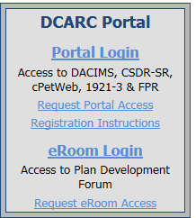

* Certificate Confirmation
* Login Screen
* If not registered, register here.
* CADE Portal Home
  + Other Applications – cPet Web
  + Tab other cPet Functions
  + Convert Files to XML
    - Browse to select files
    - 1921 then 1921-1
    - Covert – Save
  + Zip File goes into folder
  + Go to Folder where Zip File is located
    - Copy XML and Visual Verification to folder
    - Change “your file” to appropriate hull designation
  + Go back to CADE
    - Click Return to CADE Portal
    - Click CSDR – SR
  + Go to Upload Home
    - Select files XMLs first then 1921-1 next
    - Data Set = LCSXX_1921, 1921-1 – Click Validate
* To Delete the current data set:
  + Go to Submission History
  + Enter Submission ID – Click on it
  + Delete (Black “X”)
* Importing WBS Dictionary instead of CSDR
  + No need to convert or rename; simply upload